Blend Master Database Design Document

# Entity Conceptual Model

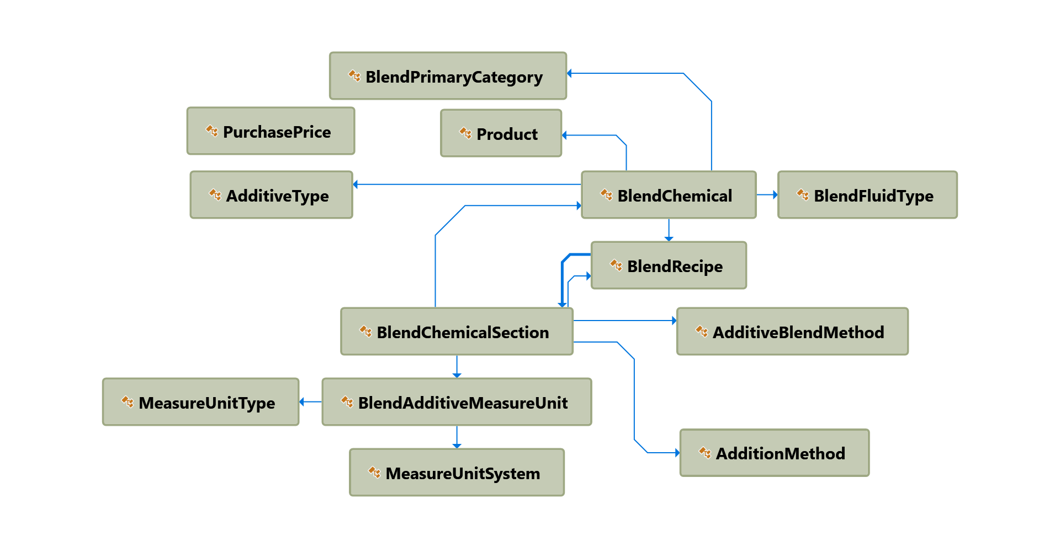

# Component Model

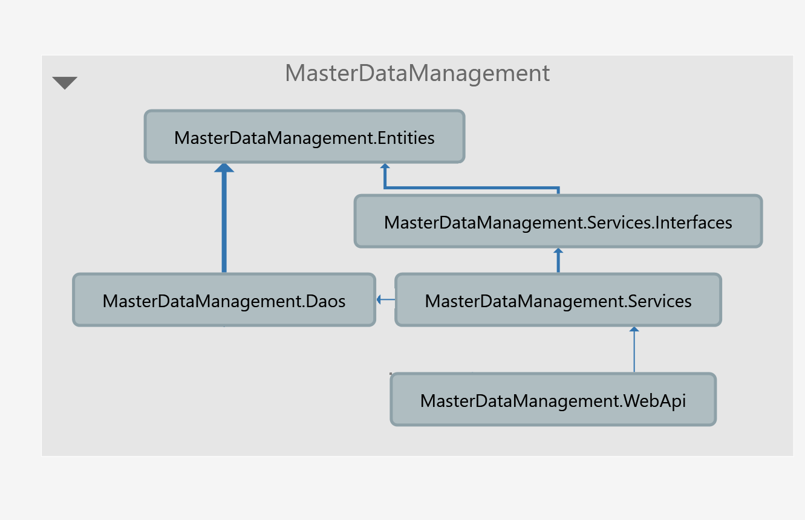

# System Environment

* Windows Server 2012 R2
* IIS 8.5
* .Net Framework 4.5+
* .Net Core 1.1 & 2.0
* .Net Standard 2.0
* SQL Server 2016

# Application APIs

1. Currently we are working on Cost API which feeds in recipe and return a cost number based on purchase price.
2. We have an application named Bulk Plant Calculator, which has the blend chemical breakdown feature. This will be easily to build out Blend Chemical Breakdown API.

# Question To Be Answered

1. Is Buyer’s Guide is same as Purchase Price?